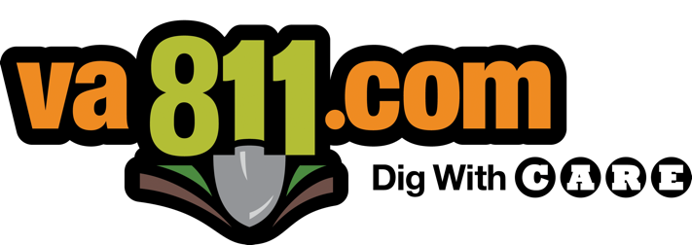

The Virginia 811 Scholarship Program

Passion to serve, dedication to safety.

Virginia 811 Mission
To operate a quality-driven, mission-critical, time-sensitive, and employee-focused organization that provides an underground damage prevention safety program for all Virginia stakeholders by continually improving the effectiveness of our quality management system as it pertains to meeting all relevant requirements while emphasizing a positive customer experience.

Apply for the Virginia 811 Scholarship!
The Virginia 811 Scholarship Program awards one (1), one-year, $1,500 college scholarships for Virginia students and/or adult learners planning to attend an accredited community college, trade school of four-year college or university by the following fall who meet the following criteria.

Virginia 811 Scholarship Eligibility.
- Applicants must be Virginia residents.
- High school applicants must be a 2024 graduating high school senior and have a current GPA of 3.0 or higher. Applicants must be planning to attend either:
  - A Virginia community college
  - A Virginia-accredited trade school
  - A four-year, accredited, college or university by the following fall after graduation
- Name and address of the Member Utility at which the student’s parent or legal guardian works, including the contact information of the parent or legal guardian’s direct supervisor.
- Applicants must successfully complete the Basic C.A.R.E. Module (Training Only) as a “Homeowner” prior to applying for this scholarship and include a screenshot of the course completion screen in Section 1-4 PDF (see PDF details in the Guidelines section).
The Basic C.A.R.E. Module is found here: https://partner.its-training.com/va811/index.html.
If selected as a recipient of the Virginia 811 scholarship program
- Interviews may be conducted (by phone or in person).
- Before funds are dispersed the following information must be provided Letter of acceptance from college, university, community college, etc., and/or current year billing statement (must include applicant’s name and institution’s name and address).

Guidelines – 2024 Graduating High School Seniors
The student can submit sections 1-4 (along with the Basic C.A.R.E. Module Training completion screenshot) in one PDF document. Be sure to clearly title each section. The student will be the sole contributor to and creator of the submission document. Please note that all submissions will be the property of Virginia 811 and used at our discretion.

Section 1: Student Introduction
In this section, the student introduces him/herself. The student should concentrate on hobbies, favorite academic subjects, and any information supporting that the student works with others as a team, demonstrates leadership skills, and/or has contributed to improving his/her community.

Section 2: Education / Extracurricular Activities / Work Experience
Please provide the following information in this section:
• Name of school the student is currently attending and current GPA.
• Name of schools to which the student is applying or planning to attend.
• Sports, clubs, and civic organizations with participated in.
• Volunteer work in which the student has participated during high school.
• Student employment history.

Section 3: Career Goals (300 words or less)
What Virginia community college, accredited trade school/ workforce curriculum program, or University does the student plan to pursue, and how will this education contribute to the applicant reaching their career goals? How will this curriculum and career path help contribute to underground utility damage prevention and assist in the mission of Virginia 811?

Section 4: Transcript and Letters of Recommendation
In addition to the application submission, students must provide a scanned copy of their high school transcripts and two recommendation letters. One letter should be from a current teacher, and one letter should come from an employer, supervisor, coach, or other individuals who have worked closely with the student in a professional manner and is familiar with the student’s work ethic and commitment to safety.

Guidelines – Adult Learners
Adult learners can submit sections 1-4 (along with the Basic C.A.R.E. Module Training completion screenshot) in one PDF document. Be sure to clearly title each section. The applicant is the sole contributor to and creator of the submission document. Please note that all submissions will be the property of Virginia 811 and used at our discretion.

Section 1: Adult Learner Introduction
In this section, the applicant introduces him/herself. The applicant should concentrate on details about their interest in their intended career track and provide the name of the Virginia community college, accredited trade school/workforce curriculum program or University they are applying to, along with any information supporting that the applicant works with others as a team, demonstrates leadership skills, and/or has contributed to improving his/her community in regard to underground utility prevention .

Section 2: Education / Work Experience
Please provide the following information in this section:
• Name of school currently attending and current GPA (if applicable).
• Name and address of current employment and job description and/or current job responsibilities (if applicable).
• Provide any work associations and/or civic organizations participated in.
• Brief employment history or resume.

Section 3: Career Goals (300 words or less)
What Virginia community college, accredited trade school/ workforce curriculum program or University does the applicant plan to pursue, and how will this education contribute to the applicant reaching their career goals? How will this curriculum and career path help contribute to underground utility damage prevention and assist in the mission of Virginia 811?

Section 4: Transcript and Letters of Recommendation
In addition to the application submission, applicants must provide a scanned copy of one recommendation letter. This letter should be from an employer, a current teacher, or another individual who has worked closely with the applicant professionally and is familiar with the applicant’s work ethic and commitment to safety.
All applications must be received by 5 PM Friday, June 14, 2024. Applications received after the due date or not submitted in their entirety will not be considered. Winners will be announced by phone, email, and written letter.
Please email applications to Nikki Turpin at NTurpin@VA811.com. Also please get in touch with Nikki Turpin with any questions or requests for more information.
*All submissions are the sole property of Virginia 811 and can be used at our sole discretion. *

